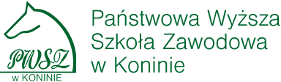
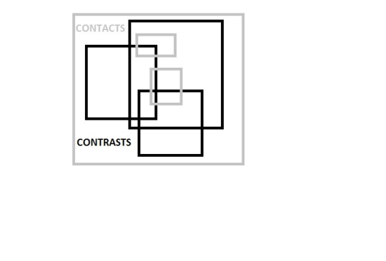
STATE UNIVERSITY OF APPLIED SCIENCES IN KONIN, POLAND
CONTACTS & CONTRASTS:
Language, Literature, Culture
KONTAKTE UND KONTRASTE:
Sprache, Literatur, Kultur
KONTAKTY I KONTRASTY:
Język, Literatura, Kultura

29-31 May, 2017
Venue: Conference Centre, Konin, Popieluszki str. no. 4, Poland

FIRST CIRCULAR & CALL FOR PAPERS
Konin is located in the central part of Poland, situated on the banks of the river Warta. Its history dates back to the 12th century and now Konin is a dynamic area in the Wielkopolska Province, developing in the fields of culture and education. It is a region of historical monuments, surrounded by forests and numerous lakes.

Conference chairs:
Barbara Lewandowska-Tomaszczyk & Anna Stolarczyk –Gembiak
(English & Polish) (German & Polish)
Conference secretaries: Marta Woźnicka, Ewa Konieczna
IT support Grzegorz Pawłowski
Languages of the conference: English, German, Polish

Mailing Address:
Contacts & Contrasts
State University of Applied Sciences in Konin
Faculty of Philology
Wyszyńskiego 3C
62-510 Konin
Poland

E-mail address: cc@pwsz.konin.edu.pl
Conference website: www.cc.pwsz.konin.edu.pl

CALL
The Department of Research in Language, Literature and Translation of the Faculty of Philology at the State University of Applied Sciences in Konin invites abstracts of papers, posters and thematic sessions in areas of research on

contacts, comparison and contrasts in languages, literatures and cultures,
including allied fields in the cognitive, social and communication sciences.

We particularly encourage submissions relevant to the proposed topics, detailed below.

Topics include (but are not restricted to):
Discourse and intercultural communication
Social interaction
Contrasts and conflicts
Identity and hybridity
Media in contrast
Literary genres and styles across languages and cultures
Contrasts in languages and cultures
Contact Linguistics
Foreign languages & international contacts
Study abroad
International professional discourses
Presenters will be given 30 minutes for presentation and a question period. Accepted papers will be published in a collective volume.

Plenary speakers include:

Professor Lucile Desblache (Roehampton University, London)

Professor Hubert Orłowski (Polish Academy of Sciences, Samuel Bogumil Linde University of Foreign Languages, Poznań)
Professor Mirosław Pawlak (State University of Applied Sciences in Konin, Adam Mickiewicz University in Kalisz)
Professor David Pichaske (Southwest Minnesota State University, Marshall, MN)

Professor Eliza Pieciul-Kamińska (Adam Mickiewicz University, Poznań)

Professor Hanna Pułaczewska (University of Szczecin)

Professor Geoffrey Williams (Université de Bretagne-Sud, Lorient)

ABSTRACT SUBMISSION

Thematic sessions
- Theme session convenors should submit their theme session proposals
directly to the conference organisers (by email: cc@konin.edu.pl ) in a
.pdf and a .doc(x) format. Theme session proposals should include:
- Session title, name and affiliation of the theme session convener, an introduction
of up to 400 words explaining the theme, a list of the authors and titles
of the individual papers, and all abstracts for the theme session in
suitable order.
Individual papers & posters
Please mark PAPER or POSTER with the title of your abstract

• Submit your abstract(s) in doc(x). and pdf formats with the filename labelled:
Name.PaperTitle.doc(x)/pdf
e.g.,
Smith_Discourse_Function_of_Negatives_in_ German_and_English.doc(x)/pdf
• Please include up to ten keywords in the abstract.

• Limit abstracts to two pages in length, inclusive of data and references. Use Times Roman 12 p. Incorporate data into the main text of the abstract, not on a separate page.

CONFERENCE FEE

The conference fee includes lunches, conference dinner, tea/coffee breaks, conference materials and the publication of the post-conference volume. Costs of travel, accommodation and the excursion are covered by the participant.

Early bird (till 30 March, 2017): 450 PLN – 160 Euros

Regular (after 30 March, 2017): 490 PLN – 180 Euros

Deadline for fee payment - 20 May 2017

Participants interested in the excursion to Basilica (Social Programme) should add 20 PLN – 6 Euros to their payment.

Bank transfer and exchange costs are paid by participants.

Fees should be paid to:
(Heading: first name_family name_contacts&contrasts (+excursion))
Państwowa Wyższa Szkoła Zawodowa w Koninie
ul. Przyjaźni 1
62-510 Konin
BANK BZWBK: 67 1500 1461 1214 6002 7586 0000

TRAVEL

By plane. The closest airports to the town are Warsaw Chopin Airport (220 km), Warsaw Modlin Airport (230 km), Poznań Ławica Airport (100 km), Lodz Wladyslaw Reymont Airport (100 km). Warsaw, Poznan and Lodz offer train services to Konin.
By train. There are regular direct train services from Poznań with an average journey time of 60 – 90 min and from Warsaw with an average journey time of 150 min. Train services from Lodz Kaliska or Łódź Widzew Stations to Konin (120 min) may require changing the trains at an intermediate station.

By car. Konin is conveniently located on the A2 Motorway which runs from the western border to Warsaw. There are also good road links from the north and south via State Road 25

ACCOMMODATION

(dealt with individually by each participant directly with the hotel) :

Hotels

“Konin”, central Konin ; offers rooms in two standards ** and ***, 2.7 km from the conference venue
www.hotelkonin.pl

“Pałacyk”, central Konin, ****, 2.5 km from the conference venue
www.hotel-konin.com
„Blues Hostel”, old town, budget, 5 km from the conference venue
www.blueshostel.pl
„Ogonowski”, old Konin, ***, 5.8 km from the conference venue
www.ogonowski.com.pl

SOCIAL PROGRAMME

Conference dinner (included in the conference fee)

Excursion to the Basilica of Our Lady of Lichen - a place of Marian apparitions, center of pilgrimages and religious cult; ( 20zł/ 6 Euros), excursion will take place on 2nd day of the conference in the afternoon.

IMPORTANT DATES

Conference dates: 29-31 May 2017

Abstract submission (thematic sessions): 1 February 2017

Notification of theme session acceptance: 15 February 2017

Abstract submission (individual papers & posters): 1 March 2017

Notification of papers and posters acceptance: 15 March 2017

Early-bird registration and fee payment: 30 March 2017

Regular registration and fee transfer deadline: 20 May 2017

